**Import the required libraries:**

1. *numpy*: numpy array implementation is faster than python array. As machine learning algorithm will require array as input.
2. *Matplotlib*: For working with graph and chart
3. *Pandas*: importing dataset and creating the matrix of features and dependent variable vector.

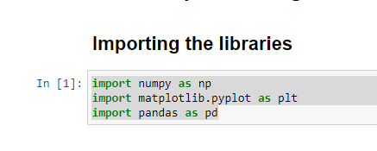

**Important**: In any dataset that we will train the machine learning with, there will be features and the dependent variable vector.

For example, in this dataset, features (independent variable) are country, age, salary. The dependent variable vector is purchased.

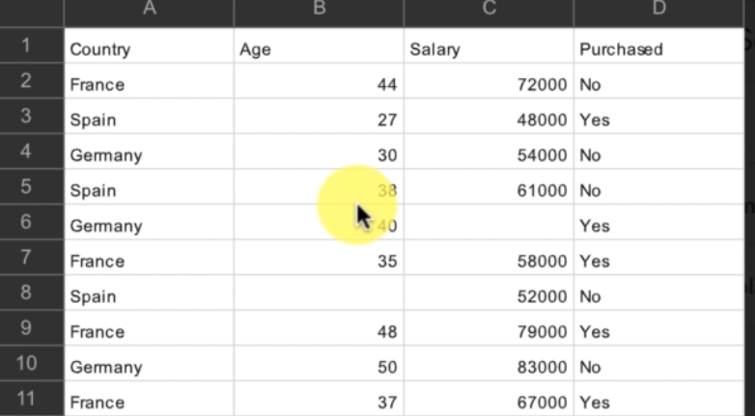

**Importing the dataset:**

